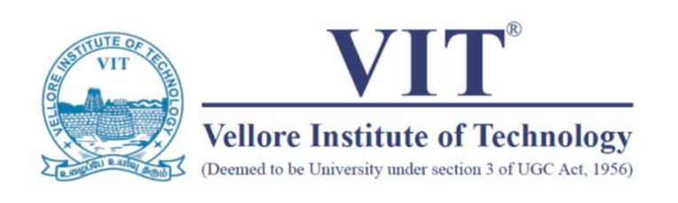

*Report on Co-Curricular activities done as a part of*

**ACXC165N Enriching Experience Through Mathematics**

Submitted by

**Abhinav Dinesh Srivatsa**

**21BDS0340**

To

Professor JAGADEESH KUMAR M.S

Winter Semester, 2022 – 2023

Table of Activities

|  |  |  |  |  |
| --- | --- | --- | --- | --- |
| S. No. | Events/Activities | Date | Hours Spent | Page No. |
| CO 1 | To apply science, engineering, management and technology to understand real world problems | | Hours: 30 | Marks: 30 |
| **Activities :** Participation in events like orientation session, training, guest lecture, workshop & internal competitions, organized by associated technical club/ chapter/ teams | | | | |
| 1 | CodeCraft | 5th May 2023 | 2 | 3 |
| 2 | Mathflix | 20th May 2023 | 2 | 4 |
| 3 | Triple Integrals | 22nd May 2023 | 2 | 5 |
| 4 | SDG Hackathon | 7th June 2023 | 24 | 6 |

|  |  |  |  |  |
| --- | --- | --- | --- | --- |
| S. No. | Events/Activities | Date | Hours Spent | Page No. |
| CO 2 | To gain practical knowledge about best practices in chosen domain | | Hours: 30 | Marks: 30 |
| **Activities :** Gaining of practical knowledge through participation in outreach activities, field visits and relevant events | | | | |
| 5 | Code & Create | 6th May 2023 | 3 | 7 |
| 6 | Dez-O-Quest | 6th June 2023 | 24 | 8 |
| 7 | Riddlanza | 19th August 2023 | 3 | 9 |

|  |  |  |  |  |
| --- | --- | --- | --- | --- |
| S. No. | Events/Activities | Date | Hours Spent | Page No. |
| CO 3 | To master team building and leadership skills | | Hours: 30 | Marks: 30 |
| **Activities** **:** Participating / Organizing / Volunteering for events during graVITas organized by the associated chapter/ technical club thereby enhancing and exhibiting the team building and leadership skills Representing the institute as a part of technical Club/ Chapter/ team in events or competitions conducted by other institutes | | | | |
| 8 | Math Mayhem | 14th August 2023 | 2 | 10 |
| 9 | Numerical Nirvana | 15th August 2023 | 2 | 11 |
| 10 | DataSphere | 16th August 20323 | 2 | 12 |
| 11 | Geometric Groove | 18th August 2023 | 4 | 13 |
| 12 | Masterminds of Mathematics | 5th September 2023 | 2 | 14 |
| 13 | MERNQuest | 1st October 2023 | 2 | 15 |
| 14 | Math Piece | 10th October 2023 | 2 | 16 |
| 15 | Statistical Snapshots | 22nd October 2023 | 2 | 17 |
| 16 | MATLAB Mastery Challenge | 24th October 2023 | 2 | 18 |
| 17 | EcoInnovate | 17th November 2023 | 2 | 19 |
| 18 | Fibonacci Fiesta | 23rd November 2023 | 2 | 20 |
| 19 | MATLAB Masters | 24th November 2023 | 2 | 21 |
| 20 | Matrix Masters | 25th November 2023 | 2 | 22 |

1. CodeCraft

CodeCraft was an invigorating college event that delved into the fundamental realms of web development. The two-hour session was a captivating journey through the building blocks of the digital world—HTML, CSS, and JavaScript. As we gathered in a dynamic atmosphere buzzing with excitement, expert speakers led us through the intricacies of these coding languages.

The event commenced with a comprehensive exploration of HTML, the backbone of web content, where we learned to structure information effectively. Transitioning seamlessly into CSS, the session empowered us to enhance our web creations with style and design. The practical insights shared during this segment not only improved our understanding but also fueled our creativity.

The final leg of CodeCraft was dedicated to JavaScript, the dynamic scripting language that adds interactivity to web pages. Through hands-on exercises, we delved into the world of functions, variables, and event handling, gaining valuable insights that bridged theory with application.

CodeCraft not only equipped us with essential coding skills but also fostered a sense of camaraderie among attendees. The collaborative spirit and newfound knowledge made this event a cornerstone in our journey into the vast realm of web development.

1. Mathflix

Attending VITMAS' MathFlix event at the Ambedkar Auditorium TT on May 20, 2023, was a truly enlightening experience. The chosen film, "The Imitation Game," seamlessly blended mathematics with storytelling, unfolding the compelling narrative of Alan Turing. As the auditorium lights dimmed, the movie took center stage, showcasing the real-world applications of mathematics in code-breaking and historical significance.

What made MathFlix exceptional was its ability to turn a mere screening into an educational spectacle. Insightful commentary from speakers elevated the experience, bridging the gap between mathematics and storytelling. The event not only entertained but also left a lasting impact, instilling a newfound appreciation for the subject.

The Ambedkar Auditorium TT provided a fitting backdrop, enhancing the intellectual ambiance of the evening. MathFlix succeeded in highlighting that mathematics is not confined to textbooks; it's a dynamic force shaping history and our understanding of the world. This inaugural event was a testament to the exciting possibilities when mathematics takes the spotlight in cinema, leaving me eagerly anticipating future editions of MathFlix.

1. Triple Integrals

Immersed in the Triple Integrals Workshop with Matlab, hosted by VIT Mathematical Association on May 22, 2023, my virtual learning experience was both enlightening and hands-on. Led by VITMAS core member Nikhil Goyal, the session on YouTube from 10:00 am to 12:00 pm provided valuable insights into solving triple integrals.

Nikhil's expertise shone as he navigated us through the complexities of triple integrals, emphasizing their practical applications in engineering, physics, and mathematics. The workshop seamlessly blended theory with application, offering a deep dive into Matlab for implementation.

The session's highlight was the hands-on segment, where participants engaged in coding exercises, gaining practical experience in visualizing integrands and exploring various coordinate systems. Nikhil's adept guidance ensured accessibility for participants of all mathematical backgrounds.

As the workshop concluded, I left with not only a clearer understanding of triple integrals but also the ability to apply this knowledge using Matlab. The VIT Mathematical Association curated a valuable opportunity, bridging the gap between theoretical concepts and real-world application. Kudos to Nikhil Goyal and VITMAS for orchestrating a dynamic and enriching event. I eagerly await future opportunities to explore the fascinating world of mathematics with VITMAS.

1. SDG Hackathon

In the culminating event of Yantra Innovation Week 2023, I enthusiastically participated in the hackathon that championed the Sustainable Development Goals endorsed by the United Nations and enforced by the G20. The hackathon served as a platform to channel innovative thinking towards making a tangible impact on our planet.

With sustainability as the core focus, participants were encouraged to generate ideas that addressed global challenges and contributed to the betterment of society. The event resonated with the urgency of the sustainability revolution, inspiring us to think beyond conventional solutions.

The diversity of participants and the fusion of creative minds created an electrifying atmosphere. Teams collaborated to devise solutions that ranged from renewable energy initiatives to eco-friendly product designs and sustainable urban planning. The hackathon wasn't just a competition; it was a collective effort to drive positive change.

As the event concluded, the sense of accomplishment was palpable. The Yantra Innovation Week hackathon not only celebrated innovation but also underscored the importance of harnessing creativity for sustainable development. I left the hackathon with a profound belief in the power of innovation to address global challenges, and I am eager to see the impact of these sustainable ideas in the broader context of the sustainability revolution. Yantra Innovation Week's hackathon was a beacon of hope, showcasing that, indeed, ideas have the power to change the world for the better.

1. Code & Craft

Engaging in the Code & Craft session was a dynamic exploration into the art of creating concise and well-crafted HTML, CSS, and JavaScript code. The session provided a collaborative platform to interact with fellow enthusiasts, fostering an environment conducive to learning and contributing to the craft of coding.

Led by knowledgeable facilitators, the session commenced with an emphasis on the importance of precision in coding. Attendees were encouraged to share insights, tips, and techniques for creating efficient code, enhancing both functionality and aesthetics.

The interactive nature of the session facilitated real-time collaboration, allowing participants to exchange ideas and receive instant feedback on their code snippets. From refining HTML structures to perfecting CSS styles and incorporating efficient JavaScript functions, the Code & Craft session covered the entire spectrum of web development.

The fusion of creativity and coding expertise was evident as participants collectively worked on crafting code that not only met industry standards but also reflected individual flair. The session not only honed coding skills but also instilled a sense of pride in contributing to a collaborative coding community.

As the Code & Craft session concluded, the shared experience left a lasting impression, emphasizing the importance of precision and collaboration in the coding process. This session was a testament to the idea that coding is not merely a technical task but a craft that thrives on creativity, collaboration, and continuous improvement. I look forward to future opportunities to refine my coding skills and contribute to the ever-evolving world of web development.

1. Dez-O-Quest

Immersing myself in the vibrant realm of design, I participated in the Designathon presented by VIT Mathematical Association. The mega event offered an array of categories, from architecture to fashion, graphics, products, film and animation, games, UI/UX design, and more. The theme, "Think-Design-Implement!!," resonated as an invitation to unleash creativity into the world.

With an esteemed panel of judges overseeing the event, the atmosphere was charged with innovation and enthusiasm. Choosing the UI/UX design category, I embarked on a journey to blend functionality with aesthetics, creating a seamless user experience. The event fostered an environment where design aficionados could showcase their talents, exchange ideas, and push the boundaries of conventional creativity.

The competition was fierce yet friendly, as participants brought forth their unique perspectives and skills. Collaborative discussions with fellow enthusiasts added a dynamic touch to the creative process. The Designathon not only encouraged individual growth but also highlighted the power of collective creativity.

As the event concluded, the anticipation of prizes added an extra layer of excitement. The Designathon by VIT Mathematical Association was not just a competition; it was a celebration of design thinking and innovation. I left inspired, having experienced the thrill of transforming ideas into tangible designs. This event served as a testament to the boundless possibilities within the world of design, and I look forward to future opportunities to push my creative boundaries with VITMAS.

1. Riddlanza

Stepping into the world of intellectual challenge, I enthusiastically participated in VIT Mathematical Association's "Riddlanza" on Instagram, unfolding on the 19th of August, 2023, starting at 7:00 pm. The event promised an evening of excitement and mental stimulation, challenging participants to exercise their mathematical prowess.

As the clock struck 7:00 pm, Instagram became the battleground for mathematical minds. "Riddlanza" commenced with a series of mind-bending riddles that intricately tested problem-solving skills and logical thinking. The event was a thrilling journey of numbers, equations, and brain-teasing fun.

Participants, including myself, eagerly embraced the challenge, racing against the clock and fellow enthusiasts to decipher the intricacies of each riddle. The virtual platform fostered a competitive yet friendly atmosphere, as mathematical enthusiasts from various backgrounds came together to showcase their problem-solving acumen.

As "Riddlanza" concluded, the virtual applause resonated the satisfaction of a mental workout. VITMAS successfully orchestrated an event that not only tested mathematical knowledge but also celebrated the joy of intellectual challenge. I left the event invigorated and eager for future opportunities to engage in the intellectually stimulating world of mathematics with VIT Mathematical Association.

1. Math Mayhem

Immersing myself in the virtual realm of mathematics, I eagerly participated in VIT Mathematical Association's "Math Mayhem" event on Instagram, held on the 14th of August, 2023, starting at 7:00 pm. The event promised an evening filled with engaging Math Trivia, where participants could put their mathematical prowess to the test and compete with fellow enthusiasts.

As the clock struck 7:00 pm, the Math Mayhem unfolded, and the Instagram platform buzzed with excitement. The event was structured with mind-bending questions and exciting rounds, challenging participants to navigate the intricacies of mathematical concepts. The dynamic format not only tested our knowledge but also kept the atmosphere light-hearted and enjoyable.

Competing with fellow math enthusiasts added a spirited edge to the event. The shared passion for mathematics created a sense of camaraderie among participants, making the evening not only intellectually stimulating but also a celebration of the beauty inherent in the subject.

As Math Mayhem concluded, I left with a renewed appreciation for the joy of mathematical exploration. VITMAS succeeded in creating an event that celebrated mathematics in a fun and interactive way. I look forward to future Math Mayhem events and further opportunities to engage with the vibrant mathematical community at VIT.

1. Numerical Nirvana

Immersed in the captivating realm of Vedic Mathematics, I eagerly joined VIT Mathematical Association's "Numeral Nirvana" event on Instagram, unfolding on the 15th of August, 2023, starting at 7:00 pm. The event promised a unique journey into the world of ancient mental calculations and mathematical techniques from the Vedas.

As the clock struck 7:00 pm, the Instagram platform became a virtual arena for mathematical exploration. Numeral Nirvana unfolded with an enlightening quiz, challenging participants to uncover the secrets of Vedic Mathematics. The event aimed to expand our mathematical skillset, offering insights into ancient shortcuts and techniques.

Participating in the quiz provided a fascinating opportunity to delve into the wisdom of Vedic Math. The event seamlessly blended competition with camaraderie, creating an atmosphere of friendly rivalry and mutual learning. Exploring the ancient techniques not only enriched our understanding of mathematics but also added a layer of cultural and historical significance to the subject.

As Numeral Nirvana concluded, I left with newfound admiration for the elegance of Vedic Mathematics and its practical applications. VITMAS orchestrated an event that went beyond traditional mathematical learning, providing a holistic experience that celebrated the richness of mathematical heritage. I eagerly anticipate future events that continue to unravel the diverse facets of mathematics with VIT Mathematical Association.

1. DataSphere

Diving headfirst into the dynamic realm of data science, I eagerly participated in VIT Mathematical Association's "DataSphere" workshop on Google Meet, held on the 16th of August, 2023, starting at 6:00 pm. The event promised a deep dive into the world of data-driven insights, led by the expertise of JVN Ganesh, VITMAS' data science domain leader.

As the clock struck 6:00 pm, the Google Meet platform became a virtual classroom for data enthusiasts. The workshop, guided by JVN Ganesh, unfolded with a rich blend of theoretical insights and hands-on experience. From beginners to seasoned enthusiasts, the event catered to a diverse audience, providing a valuable opportunity to harness the power of data for informed decision-making.

JVN Ganesh's expertise shone as he navigated us through the intricacies of data science techniques. The interactive session encouraged questions and discussions, fostering a collaborative learning environment. The workshop wasn't just an instructional session; it was a journey into the practical applications of data science, showcasing its relevance across various domains.

As DataSphere concluded, I left with a newfound appreciation for the role of data in shaping informed decisions. VITMAS successfully curated an event that empowered participants to elevate their data science skills, thanks to the insightful guidance of JVN Ganesh. I eagerly anticipate future opportunities to delve deeper into the evolving landscape of data science with VIT Mathematical Association.

1. Geometric Groove

Immersing myself in the enchanting event hosted by VIT Mathematical Association, "Geometric Groove" on Google Meet, spanning from the 18th to the 19th of August, 2023, starting at 8:00 pm, proved to be a harmonious fusion of mathematics and art.

As the virtual meeting room came to life at 8:00 pm, the event unfolded as a unique exploration into the intersection of creativity and mathematical precision. "Geometric Groove" invited participants to craft their own math-inspired masterpieces, delving into the intricate dance between shapes and numbers.

Guided by the ethos of VITMAS, the event facilitated the unleashing of artistic flair while embracing the elegance of geometry. Participants embarked on a journey where intellect and imagination converged, resulting in a myriad of mathematically inspired artworks.

The collaborative environment on Google Meet fostered a shared appreciation for the beauty inherent in the fusion of mathematics and art. "Geometric Groove" wasn't just an event; it was a celebration of the creative possibilities that arise when mathematical concepts are translated into visually captivating expressions.

As the event concluded, I left with a deepened appreciation for the harmonious synergy between intellect and imagination. VIT Mathematical Association once again succeeded in creating an event that celebrated the multifaceted nature of mathematics, leaving participants inspired and eager for future artistic journeys within the realm of VITMAS.

1. Masterminds of Mathematics

Immersing myself in the rich legacy of mathematics, I eagerly participated in VIT Mathematical Association's "Masterminds of Mathematics" event on Instagram Live, held on the 5th of September 2023, from 7:00 PM to 9:00 PM. The event promised a captivating journey through time and the genius minds that shaped the world of numbers and theories.

As the clock struck 7:00 PM, the Instagram Live session commenced, taking participants on an exhilarating quiz tribute to legendary mathematicians. The event unfolded as a celebration of mathematical brilliance, inviting us to test our knowledge and pay homage to the luminaries who have left an indelible mark on the realm of numbers.

The quiz format seamlessly blended education with excitement, prompting participants to recall the contributions of mathematical pioneers. From groundbreaking theorems to revolutionary discoveries, the questions spanned the vast landscape of mathematical history.

"Masterminds of Mathematics" was not just a quiz; it was a collective celebration of the genius minds that have shaped the world of mathematics. The event fostered camaraderie among participants, united in their admiration for the art of numbers. As the Instagram Live session concluded, I left with a renewed passion for the profound legacy of legendary mathematicians, eagerly anticipating more opportunities to engage with the captivating world of mathematics with VIT Mathematical Association.

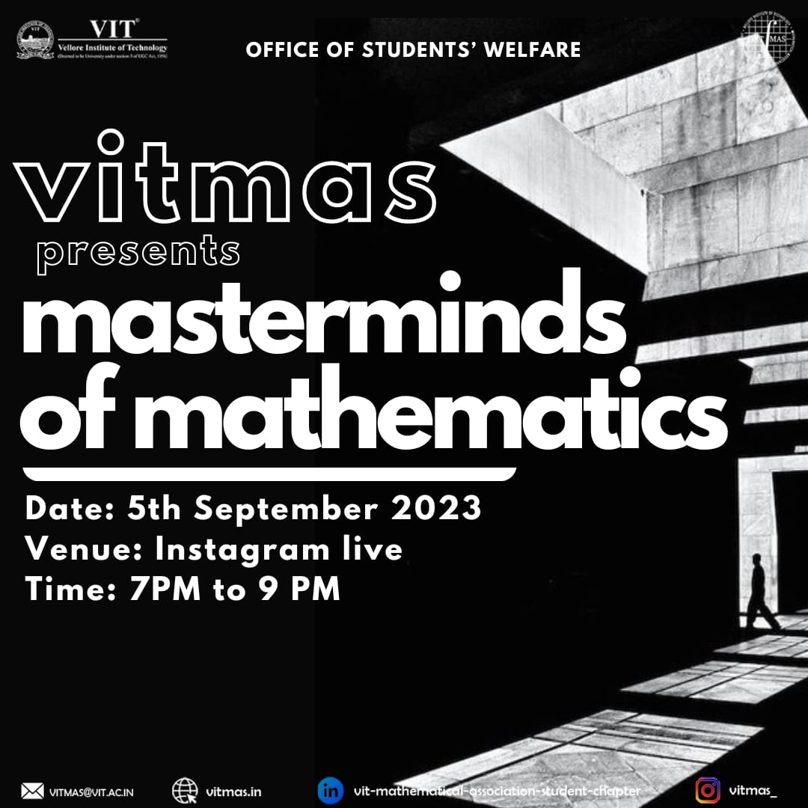

1. MERNQuest

Delving into the depths of web development, I eagerly participated in the "MERNQuest - Unraveling the Stack Enigma" workshop hosted by VIT Mathematical Association. Conducted on Google Meet on the 1st of October, 2023, from 8:00 pm to 10:00 pm, this event was a knowledge-packed journey into the intricacies of the MERN stack.

Atharv Shukla, the Technical Domain Head at VITMAS, led the enlightening workshop, guiding participants through the nuances of MongoDB, Express.js, React, and Node.js. The virtual platform became a classroom for technical enthusiasts, offering a comprehensive understanding of each component of the MERN stack.

The workshop seamlessly blended theory with practical insights, providing hands-on experience and valuable tips for navigating the complexities of web development. Atharv's expertise and interactive teaching style created an engaging environment, making even intricate concepts accessible to participants with varying levels of technical knowledge.

As the "MERNQuest" workshop concluded, I left with a heightened appreciation for the MERN stack and its application in modern web development. VITMAS successfully orchestrated an event that not only enhanced technical acumen but also inspired a newfound enthusiasm for exploring the evolving landscape of web technologies. I eagerly anticipate more learning opportunities with VIT Mathematical Association to stay abreast of advancements in the dynamic field of web development.

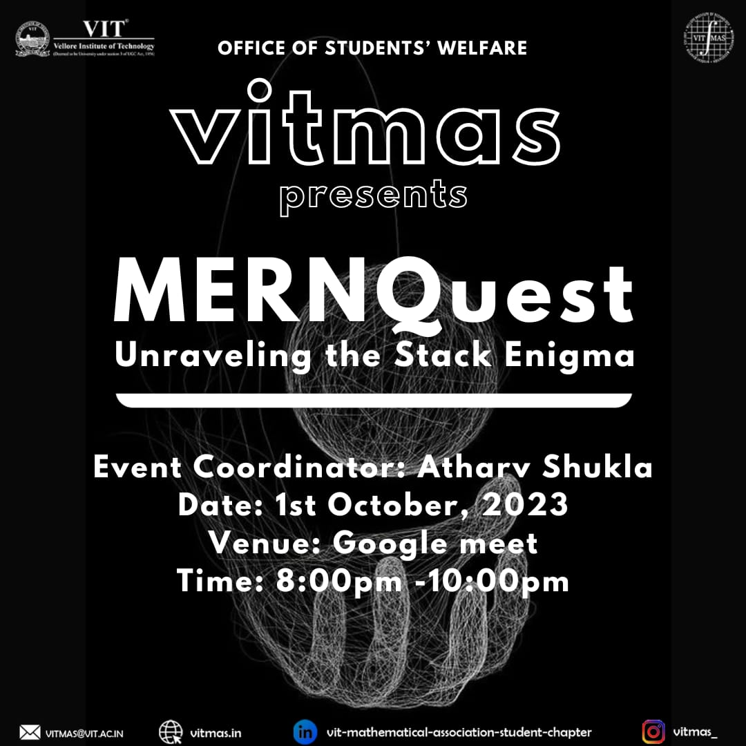

1. Math Piece

Immersing myself in the fusion of mathematical challenges and treasure hunting, I eagerly participated in VIT Mathematical Association's "Math Piece" event held at Kalpana Chawla ground on the 10th of October 2023, from 4:00 PM to 6:00 PM. The event, inspired by the anime "One Piece," promised a unique mathematical adventure.

As the clock struck 4:00 PM, Kalpana Chawla ground transformed into the setting for an exhilarating treasure hunt. "Math Piece" unfolded as an event that tested not only mathematical prowess but also problem-solving abilities. Participants, armed with numerical skills, navigated through challenging equations and deciphered numerical riddles in a quest to unlock hidden secrets.

The atmosphere buzzed with excitement as teams collaborated and competed to unravel the mathematical mysteries scattered across the venue. The event seamlessly combined the thrill of treasure hunting with the intellectual stimulation of mathematics, creating an engaging and dynamic experience for all participants.

As "Math Piece" concluded, I left with a sense of accomplishment and a newfound appreciation for the inventive ways mathematics can be integrated into real-world adventures. VIT Mathematical Association once again succeeded in orchestrating an event that celebrated the joy of mathematics while fostering teamwork and problem-solving skills. I look forward to future events that continue to explore the diverse facets of mathematics with VITMAS.

1. Statistical Snapshots

In celebration of World Statistics Day, I enthusiastically participated in "Statistical Snapshots," an event hosted by VIT Mathematical Association on their Instagram platform. The event unfolded on the 22nd of October 2023, from 7:00 PM to 9:00 PM, offering participants a unique opportunity to test their statistical knowledge and delve into fascinating facts about global data.

As the clock struck 7:00 PM, VITMAS Instagram became a virtual arena for statistical exploration. The quiz format engaged participants in a fun and interactive way, challenging them to uncover key statistical insights. The questions spanned a range of topics, from global trends to noteworthy data points, creating an intellectually stimulating experience.

The event wasn't just a quiz; it was a celebration of the power of numbers and statistics.

Participants, including myself, engaged in a collective exploration of the impact of statistics on our understanding of the world. The interactive nature of the event fostered a sense of camaraderie among participants, united by their shared interest in the fascinating realm of statistical analysis.

As "Statistical Snapshots" concluded, I left with not only an enriched understanding of global data but also a deeper appreciation for the role statistics play in shaping our perspectives. VIT Mathematical Association successfully curated an event that celebrated World Statistics Day with enthusiasm and intellectual curiosity. I look forward to future opportunities to engage with the world of numbers and statistics with VITMAS.

1. MATLAB Mastery Challenge

Diving into the world of MATLAB, I eagerly participated in the "MATLAB Mastery Challenge," an event hosted by VIT Mathematical Association on their Instagram platform. The challenge unfolded on the 24th of October 2023, from 4:00 PM to 6:00 PM, promising a thrilling quiz competition that aimed to test and expand participants' MATLAB knowledge.

As the clock struck 4:00 PM, the VITMAS Instagram account became the virtual stage for MATLAB enthusiasts. The challenge catered to both seasoned experts and those new to MATLAB, creating an inclusive space for learning and competition. The event kicked off with a series of questions that spanned the breadth of MATLAB functionalities, from basic concepts to advanced techniques.

The interactive quiz format not only tested participants' MATLAB proficiency but also provided valuable insights and learning opportunities. The friendly competition fostered a sense of community among participants, creating an environment where MATLAB enthusiasts could come together to share their knowledge and experiences.

As the "MATLAB Mastery Challenge" concluded, I left with a heightened appreciation for the versatility and power of MATLAB. VIT Mathematical Association successfully organized an event that not only celebrated MATLAB expertise but also encouraged continuous learning and collaboration within the MATLAB community. I look forward to future challenges that push the boundaries of MATLAB knowledge with VITMAS.

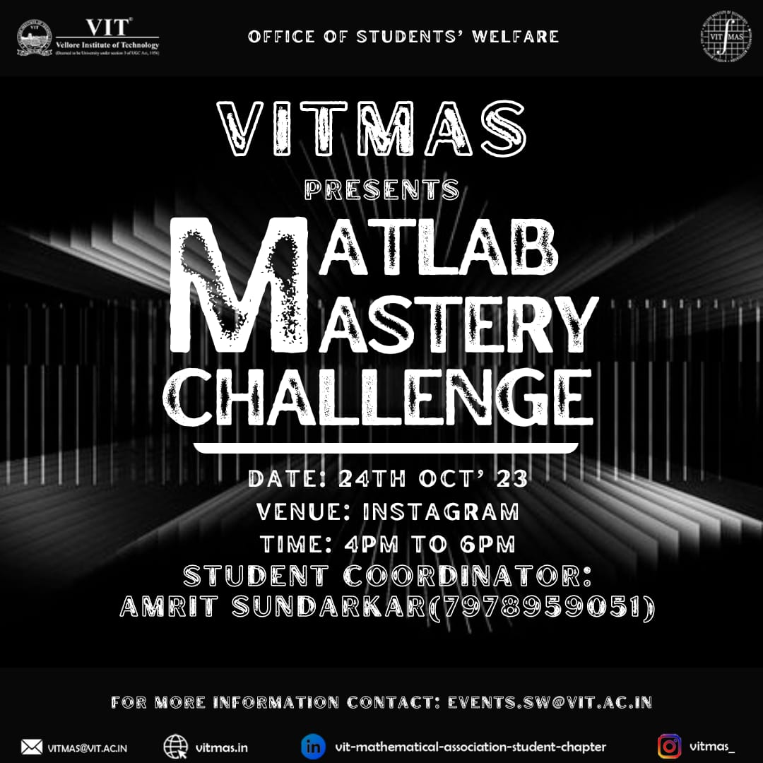

1. EcoInnovate

I had the privilege of attending the EcoInnovate event, a significant initiative aligned with Sustainable Development Goals (SDGs). The anticipation in the air was palpable as fellow EXC members gathered to explore innovative solutions for pressing sustainability challenges.

The event unfolded as a dynamic platform for knowledge exchange and collaboration. The discussions spanned a spectrum of eco-friendly innovations, from renewable energy solutions to sustainable urban planning. The diverse range of topics reflected the depth and breadth of efforts towards creating a more sustainable future.

Notably, the engaging presentations by speakers illuminated the practical applications of eco-innovation. From cutting-edge technologies to community-driven initiatives, each presentation showcased the impact achievable through sustainable practices. The interactive Q&A sessions allowed participants to delve deeper into the nuances of these solutions, fostering a sense of collective understanding.

Furthermore, the event served as a catalyst for meaningful conversations among attendees. The networking opportunities provided a chance to connect with like-minded individuals, fostering a community dedicated to driving positive change. It was inspiring to witness the passion and commitment of EXC members towards embracing sustainability in various aspects of their lives.

In conclusion, EcoInnovate was not just an event; it was a call to action. The insights gained and connections forged during this gathering have left a lasting impression, reinforcing the significance of sustainable practices in our collective journey towards a better future.

1. Fibonacci Fiesta

On the eve of November 23rd, I had the pleasure of participating in the "Fibonacci Fiesta," a captivating event hosted by the VIT Mathematical Association on Instagram. The event, dedicated to celebrating Fibonacci Day, unfolded from 9:00 PM to 11:00 PM, promising a mathematical journey through the wonders of the Fibonacci sequence.

As the clock struck 9:00 PM, the Instagram platform transformed into a virtual hub for math enthusiasts. The event kicked off with a warm welcome, setting the stage for an engaging quiz that would unravel the magic of the Fibonacci sequence. The questions, thoughtfully crafted, spanned the history, properties, and applications of this iconic mathematical phenomenon.

Participants, including myself, eagerly embraced the challenge, each question unveiling a new layer of fascination surrounding Fibonacci's contributions to the world of numbers. The interactive nature of the quiz encouraged lively discussions among participants, fostering a sense of camaraderie among those who share a passion for mathematics.

The event wasn't merely a quiz; it was a celebration of the beauty inherent in numbers. As we navigated through the Fibonacci sequence, the virtual gathering became a space where mathematical wonders were uncovered, and the joy of discovery was shared among participants.

As "Fibonacci Fiesta" concluded at 11:00 PM, the virtual applause echoed the collective appreciation for the enchanting world of mathematics. VIT Mathematical Association orchestrated an event that not only celebrated Fibonacci Day but also strengthened the bond among math enthusiasts. I left the event with a heightened sense of wonder for the magic hidden within numbers and a deepened connection to the vibrant mathematical community at VIT.

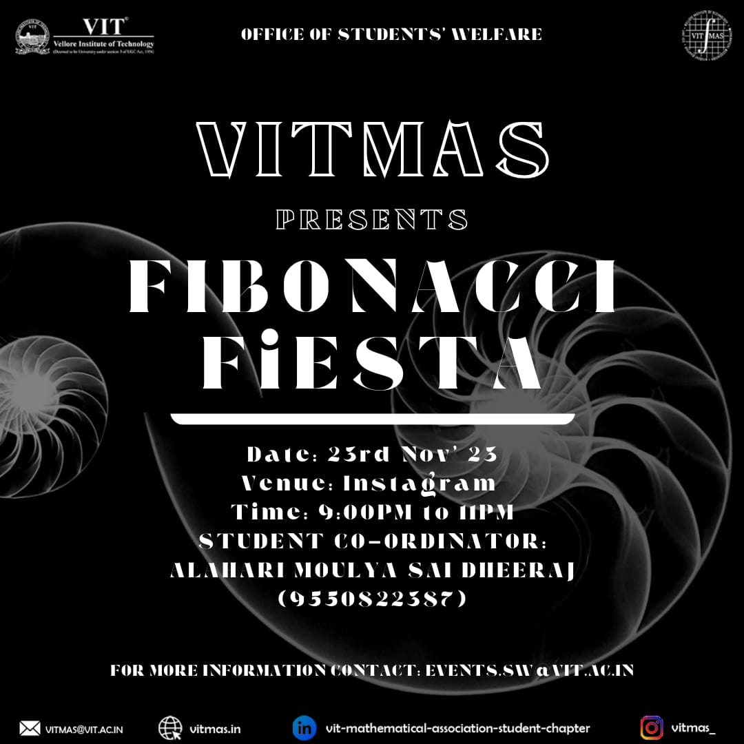

1. MATLAB Masters

On the evening of November 24th, I immersed myself in the world of MATLAB, joining the "MATLAB Masters" workshop hosted by the VIT Mathematical Association. Conducted on YouTube from 9:30 PM to 11:00 PM, the workshop promised to unravel the intricacies of MATLAB and provide valuable insights into efficient problem-solving techniques.

The virtual workshop was led by Amrit Sundarka, a core member of VITMAS, who seamlessly guided participants through the nuances of MATLAB problem-solving. The event began with a friendly introduction, creating an inclusive atmosphere for both beginners and those seeking to enhance their existing MATLAB skills.

Amrit Sundarka skilfully navigated through MATLAB's functionalities, demonstrating quick tricks and efficient coding practices. The workshop was not just a theoretical exploration; participants actively engaged in hands-on coding exercises and real-world examples. This interactive approach not only reinforced learning but also demystified the perceived complexity of MATLAB.

The content covered a spectrum of MATLAB applications, showcasing its relevance in various research and project scenarios. Participants, including myself, left with a deeper understanding of MATLAB's potential and newfound confidence in applying it to our academic and professional pursuits.

As the "MATLAB Masters" workshop concluded, the virtual space echoed with appreciation for Amrit Sundarka's expertise and the event's overall success. VIT Mathematical Association once again delivered an educational experience that empowered participants to become masters in MATLAB. I look forward to applying the skills gained and eagerly anticipate future workshops to further enhance my proficiency in MATLAB.

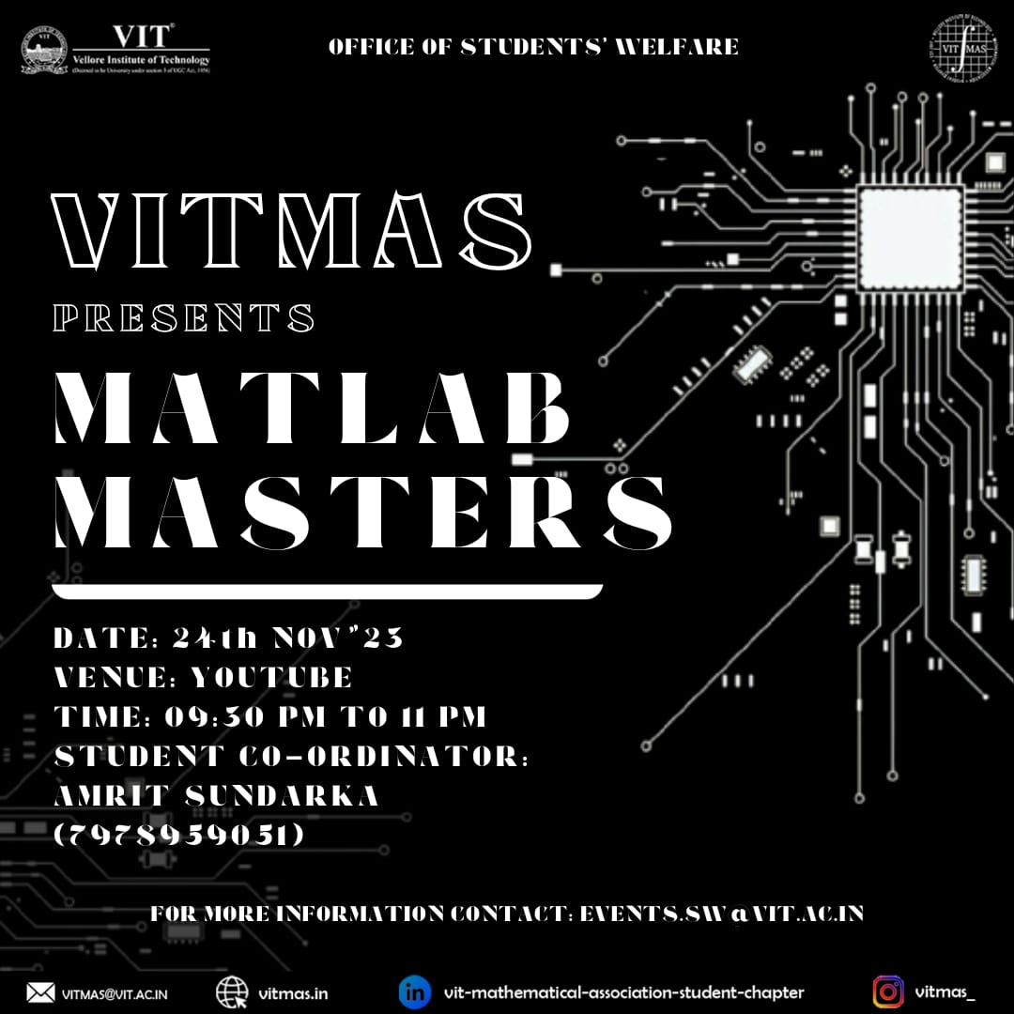

1. Matrix Masters

In the quest for mathematical mastery, I eagerly participated in the "MatrixMasters" workshop hosted by the VIT Mathematical Association. Conducted on the VITMAS YouTube channel on November 25th from 11:00 AM to 12:00 PM, this workshop promised an in-depth exploration of solving maximum and minimum of a two-variable function using MATLAB.

The workshop, skillfully led by Amrit Sundarka, a core member of VITMAS, commenced with an overview of the importance of solving two-variable functions in engineering, physics, and mathematics applications. Amrit's expertise shone through as he guided participants through the intricacies of MATLAB, emphasizing its practical applications in optimizing functions.

The hands-on experience was a highlight of the workshop, with participants actively engaging in coding exercises and real-world examples. Amrit's step-by-step guidance provided clarity on implementing MATLAB for solving maximum and minimum problems, demystifying the complexities associated with these mathematical tasks.

The workshop not only equipped participants with practical MATLAB skills but also deepened their understanding of the theoretical underpinnings of optimizing two-variable functions. The interactive nature of the session allowed for real-time problem-solving, fostering a dynamic learning environment.

As "MatrixMasters" concluded at noon, I left with a heightened appreciation for the power of MATLAB in tackling complex mathematical challenges. VIT Mathematical Association, through the guidance of Amrit Sundarka, successfully delivered a valuable opportunity for participants to enhance their skills in optimizing two-variable functions. I eagerly anticipate more such workshops to further expand my proficiency in MATLAB and its diverse applications.

